Aberfeldy School
Special Newsletter
30th October 2018

Dear Parents and Caregivers,

PET DAY:
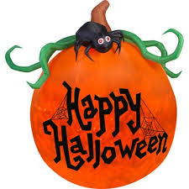
Due to the unsettled weather we are experiencing, and extremely wet grounds at present, we have decided to postpone PET DAY to NEXT Friday 9th November and hopefully the weather will be nicer.

HALLOWEEN LUNCHTIME:
Tomorrow our senior girls are planning a Halloween fun time. They have organised games, contests and dancing. You are welcome to bring a long a costume or mask to wear.

TEACHERS STRIKE ACTION:
Just as a heads up, as you are all probably aware, teaching staff (including Principals) are going on a rolling strike, with our region set to strike on Tuesday 13th November.
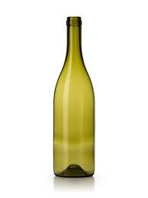
EMPTY WINE BOTTLES:
If anyone has empty wine bottles that they would like to get rid of we are requiring some at school for an activity.

Kind regards

Fran Lambert
Principal

